

# NATIONAL UNIVERSITY OF SCIENCES AND TECHNOLOGY

SCHOOL OF MECHANICAL AND MANUFACTURING ENGINEERING

**MECHANICAL ENGINNERING (ME-15)**

# PROGRAMMING:

**Lab task #5**

**SUBMITTEED BY: MUHAMMAD ALI SHOUKAT**

**REGISTRATION NUMBER: 457397**

* **Task 1:**

include<iostream>

//using namespace std;

//int main(){

// int x=1;

// do{

// cout<<"enter a number there ";

// cin>>x;

// }while(x>0);

// return 0;

//}

**Output:**

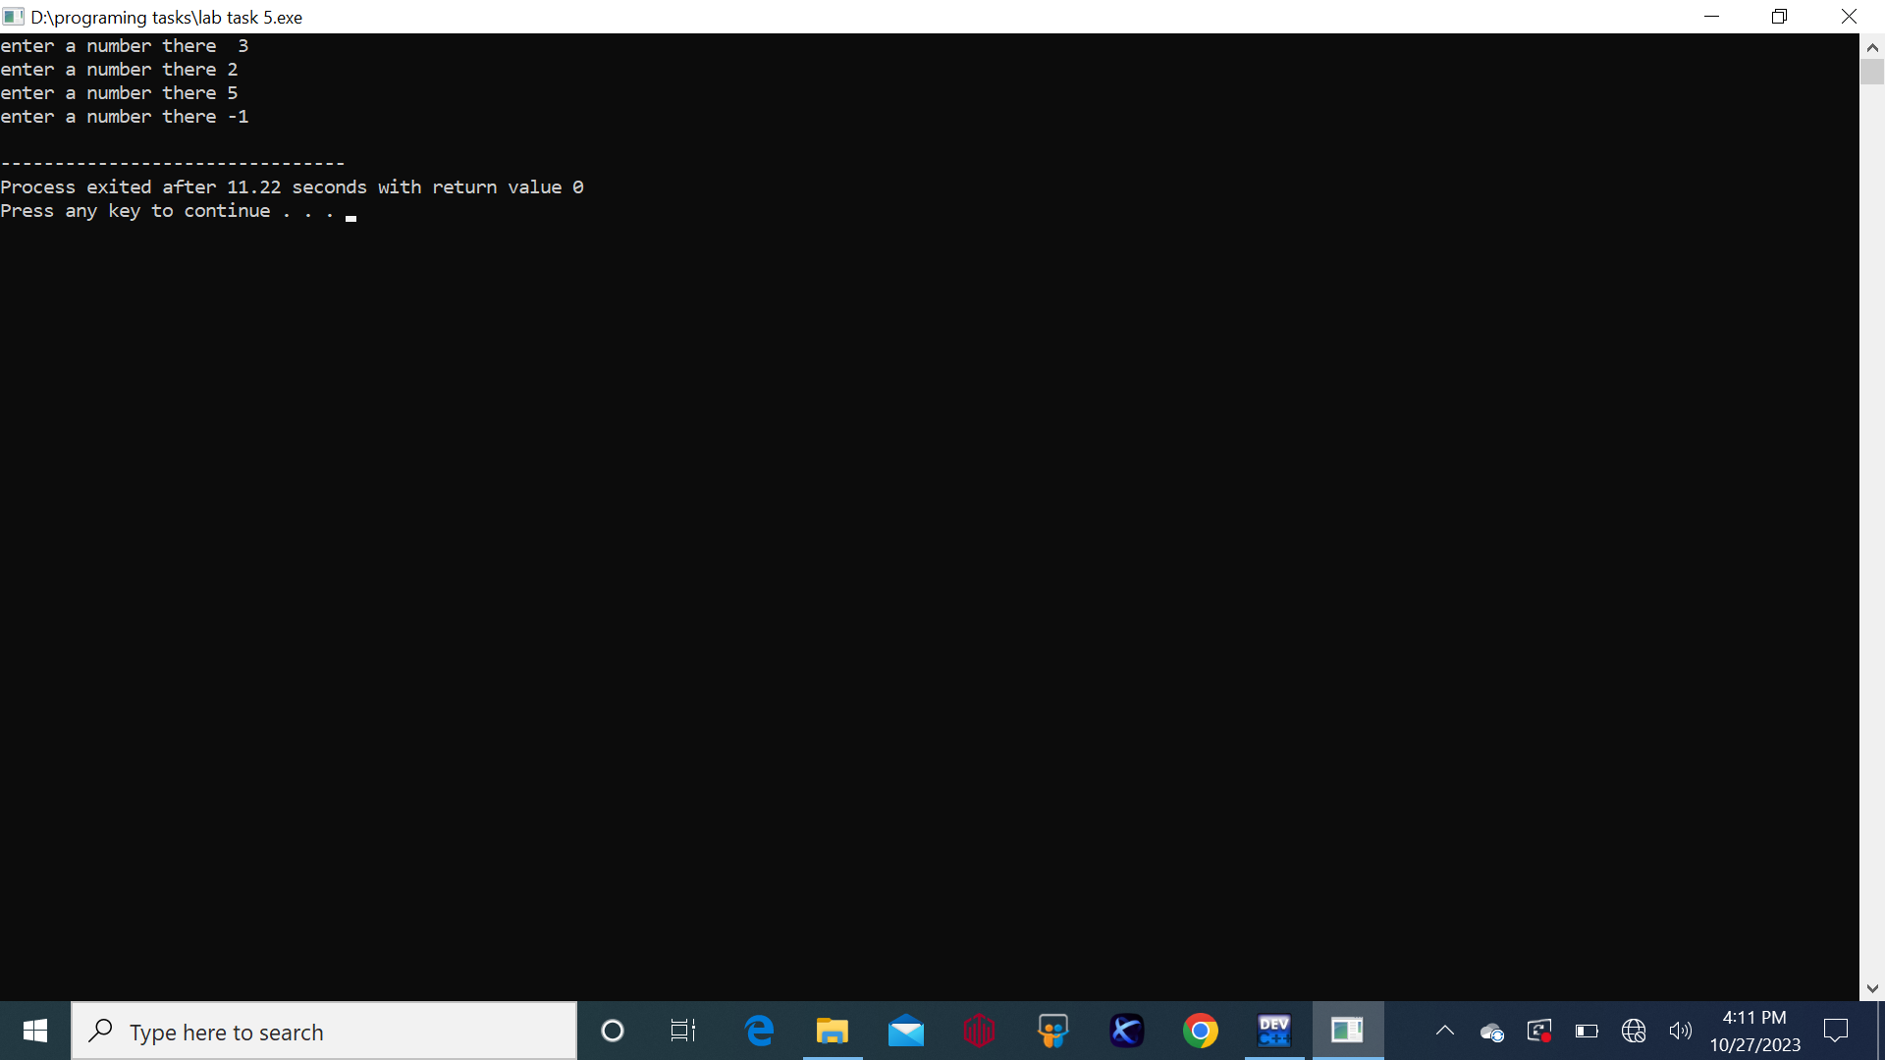

* **Task 2:**

//#include<iostream>

//#include<math.h>

//using namespace std;

//int main(){

// int num1,num2;

// char operation;

// char x;

// do{

// cout<<"enter your first number there ";

// cin>>num1;

// cout<<"enter your second number there ";

// cin>>num2;

// cout<<"enter the operation you want (+,-,*,/,%,^,)";

// cin>>operation;

// switch(operation){

// case'+':

// cout<<num1<<"+"<<num2<< "="<<num1 + num2<<endl;

// break;

// case'-':

// cout<<num1<<"-"<<num2<<"="<<num1 - num2;

// break;

// case'*':

// cout<<num1<<"*"<<num2<<"="<<num1*num2;

// break;

// case'/':

// cout<<num1<<"/"<<num2<<"="<<num1/num2;

// break;

// case'%':

// cout<<num1<<"%"<<num2<<"="<<num1%num2;

// break;

//

// case'^':

// cout<<num1<<"^"<<num2<<"="<<pow(num1,num2)<<endl;

// break;

//

//}

// cout<<" do you wnat to use it again? "<<endl<<"press y for yes and any other button for no "<<endl;

// cin>>x;

// }

// while(x=='y');

//}

**Output:**

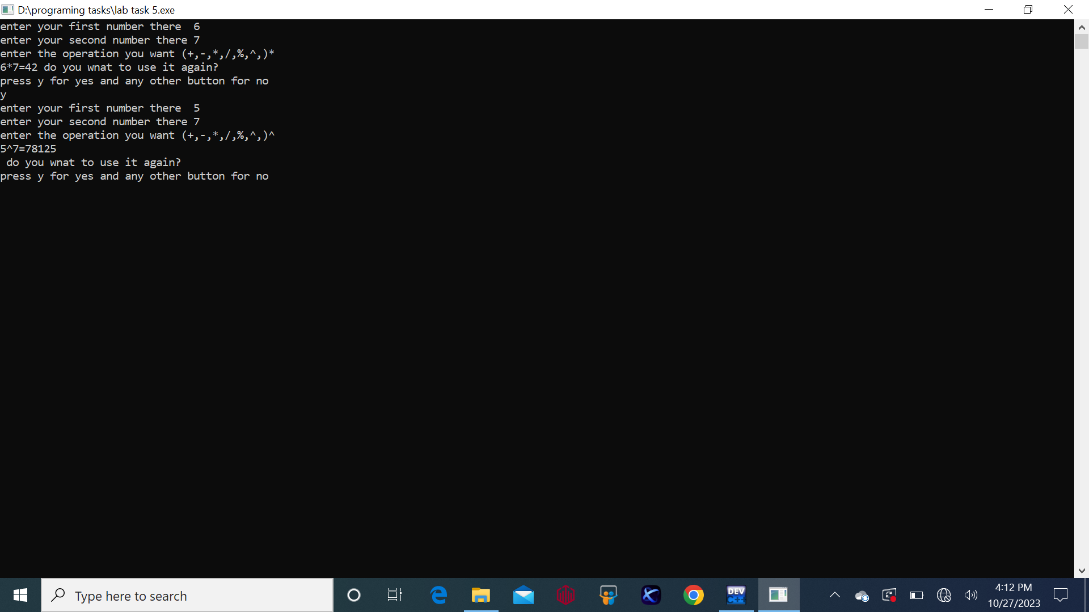

* **Task 3:**

**Part-a**

//#include<iostream>

//using namespace std;

//int main(){

// int num=2,sum=0,res;

// while(num<=100){

// res=sum+num;

// sum=res;

// num +=2;

//

//

//}

//

// cout<<"the sum of all even number between 2 and 100 is "<<res;

// return 0;

//}

**Output:**

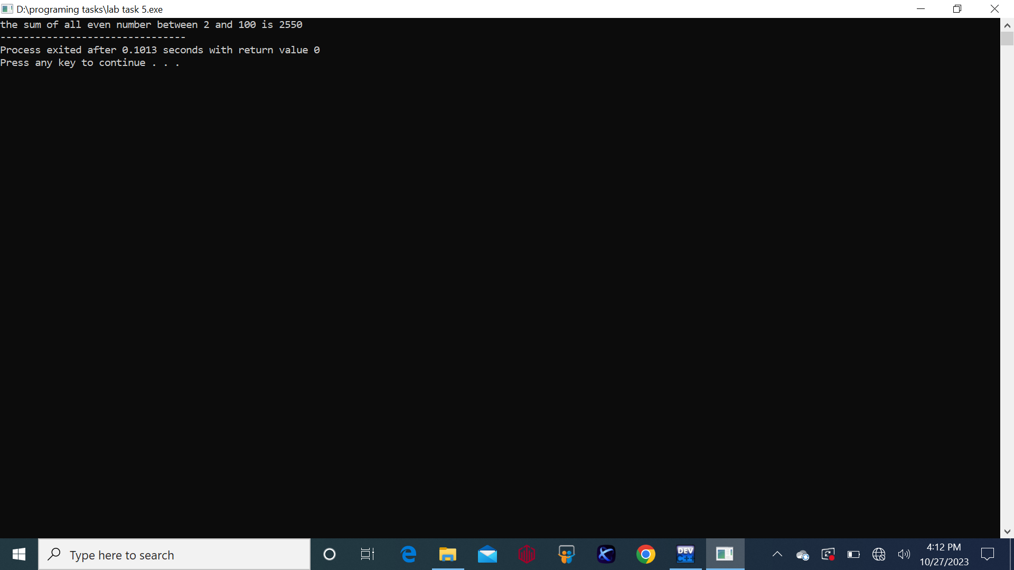

**Part-b**

//#include<iostream>

//using namespace std;

//int main(){

// int num1=1,res=0;

// while(num1<=100){

// res +=num1*num1;

// num1++;

//

// }

// cout<<"the sum of all the squares between 1 and 100 = "<< res;

// return 0;

//}

//

**Output:**

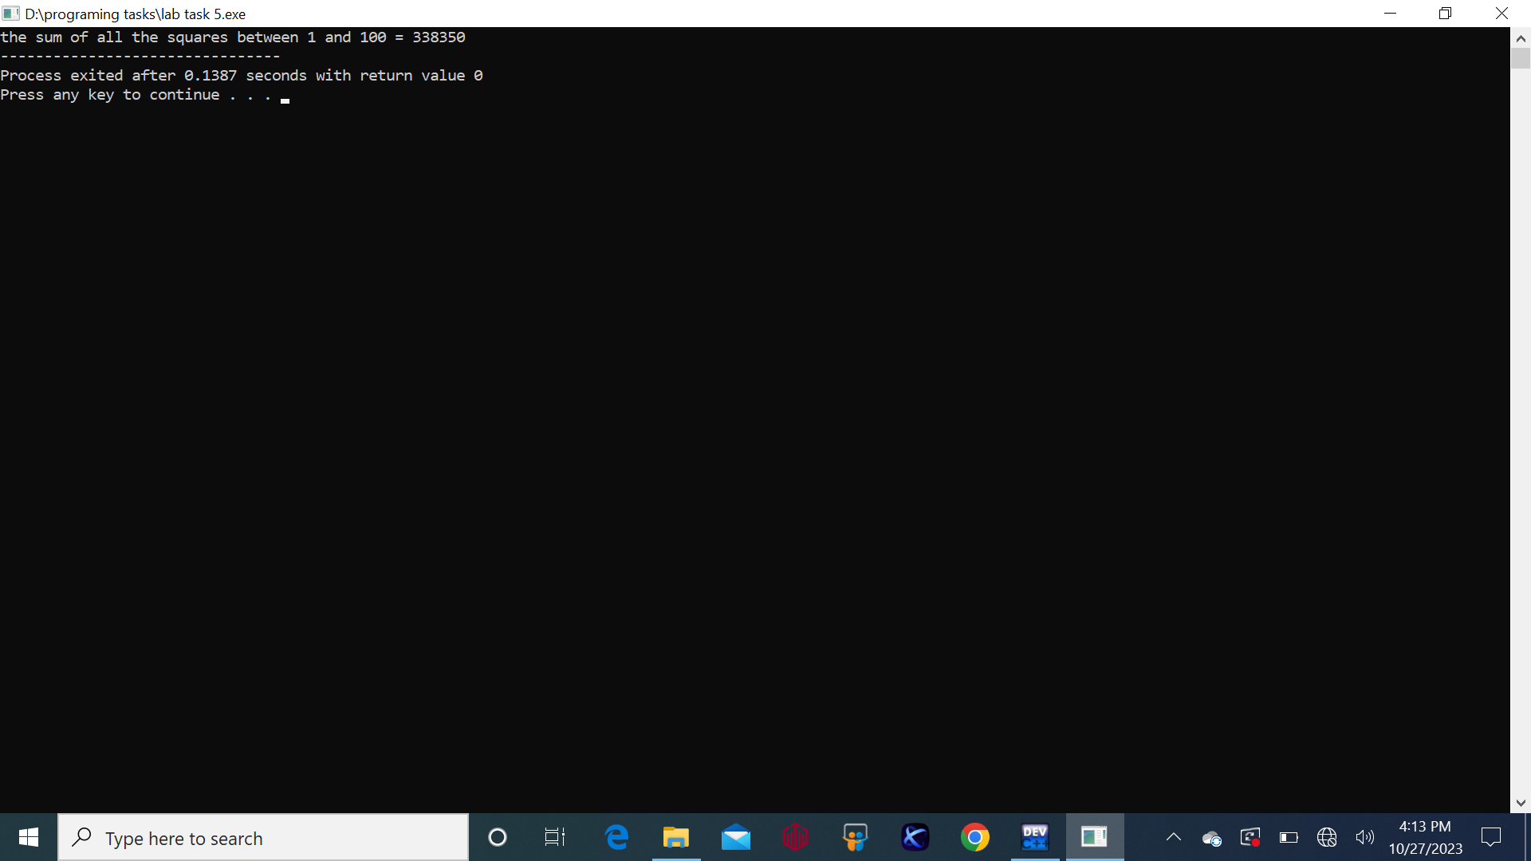

* **Task 4:**

**Part-a**

//#include<iostream>

//#include<math.h>

//using namespace std;

//int main(){

// int num1=2,num2=0,res;

// while(num2<=20){

// res=pow(num1,num2);

// num2++;

// cout<<res<<endl;

//}

// }

//

**Output:**

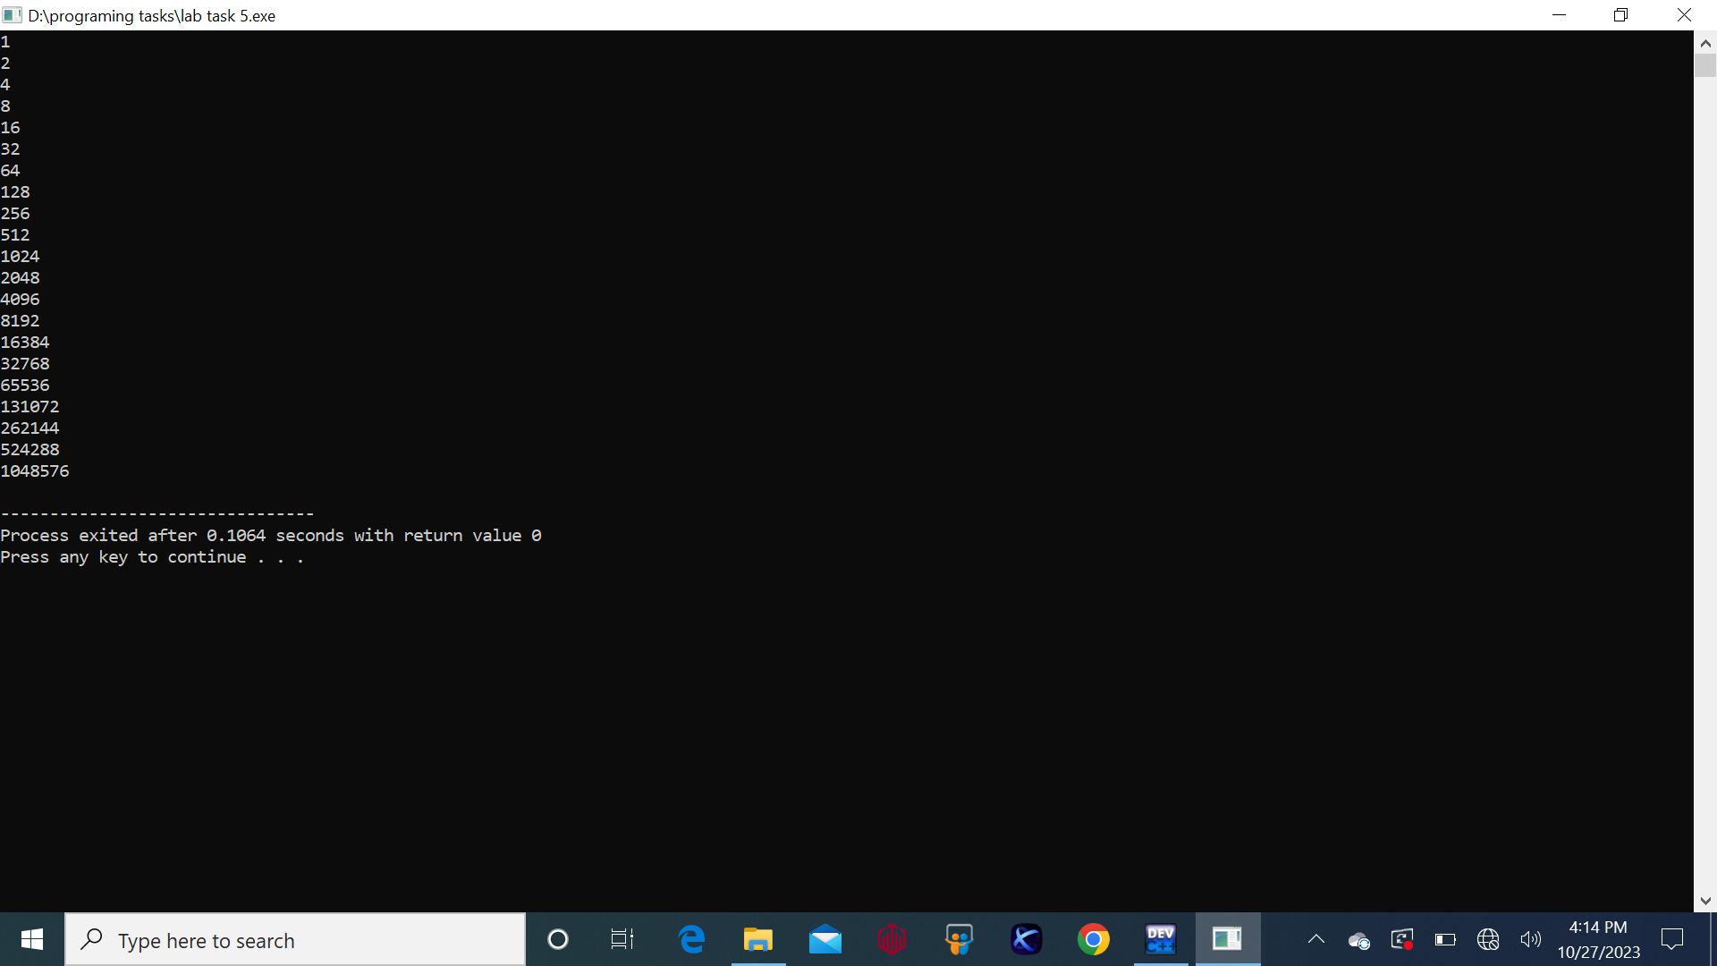

**Part-b**

//#include<iostream>

//using namespace std;

//int main(){

// int a,b,sum=0;

// cout<<"enter the values of a and b respectively ";

// cin>>a>>b;

// while(a<b){

//

// if(a%2==1){

// sum +=a;

//

// }a++;

// }cout<<"the sum of all odd number between a and b is "<<sum;

//

// return 0;

//}

**Output:**

